Name: ________________ Date: ___/___/____
Mr. Merlis Block ___3 - ACE___
C++ 1 Day of Class: _____

Karel++ Stepwise Refinement – Algorithm Design
INSTRUCTIONS: Use the grids below to plan the harvesting task, p. 62_4.

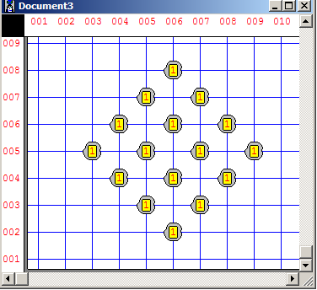

Choose one of the 4 you have drawn and briefly explain why you think it is best.

(over)

Write the task block for your algorithm, remember the “less than 10 lines” rule. Use names that are meaningful for each task. Use loops if appropriate.

task
{

}

Write the declaration of all new instructions for the Harvester

class Harvester: ur_Robot
{

}; // this semicolon is very important

