Name __________________________ Date: _______
AP CS Java - Mr. Merlis Block 4 ACE

Day 25 – SECOND QUARTER – The Beginning of Something New

Vehicle Project is OVER! Here are some of the many things we first took a look at while writing it:

- Abstract classes
  - Not all methods are completely defined.
- Sorting
  - Selection
    - Place the largest at the [n-i] index in the array. Increment i each loop so each time we are placing the ‘next highest’ in the spot ‘next to last’ each time.
  - Insertion
    - Compare consecutive entries until we find one in the wrong spot. Then determine how far to the left it should be moved. Insert it in the spot that maintains the sort up to that point.
- Searching
  - Linear/Sequential
    - Iterate through the entire list in an ordered, unchanging way. Simply go through the elements by incrementing the index.
  - Binary
    - Assuming the list is sorted and you are only looking for one occurrence, this is tremendously faster than linear. It keeps the breaking the list in half until the match is found.
- Building arrays
  - Determine how many elements in a list meet the criteria for the new array
  - Create the array at an appropriate size based upon # of elements to be placed in it
  - Copy the contents from the correct locations in the given list into the new one

Just what exactly is “Big-O”?

‘Big O’ is a measure of the efficiency of an algorithm, mainly based upon the number of comparisons it makes. We often speak of an algorithm’s best case, worst case, and average case Big O.

Let us begin by talking about the ‘Big O’ of a linear search.
What we want to know is ‘about’ how long does it take. While it is possible to clock the time required for a computer to search a list, this is dependent upon processor speed and other factors, so it’s better to look at it from a more general standpoint of the number of operations that will be performed.

If we are doing a linear search, meaning we are going to look sequentially through a list for some target, what is the least number of comparisons we’d have to make?

Well, if the item is in the first spot, then we make one comparison which is ‘true’, so we are done. So the answer is a O(1), or a “Big O of 1”.

What if the item is not in the list at all? In that case, we go through the entire list, making the same number of comparisons as items in the list, and then deduce it is not there. The worst case therefore is O(n).

The average case, when it is found in the middle, would average about n/2 comparisons. Big O, however, removes constants from the equation, so we can remove ½ from for an average O(n).
Big Oh Sorting & Searching Summary
APCS - Java

SORTS

1) Selection
a) Big O best case time - O(n²)
b) Big O ave case time - O(n²)
c) Big O worst case time - O(n²)
d) worst case data set - reverse order
e) space requirements - one array
f) other characteristics or comments - two nested loops, terribly, slow sort, inefficient for n>100 data
sets, many comparisons, could be many assignments if in reversed order, only one swap per pass of the
inner loop, no early exit

3) Insertion
a) Big O best case time - O(n)
b) Big O ave case time - O(n²)
c) Big O worst case time - O(n²)
d) worst case data set - reverse order
e) space requirements - only one array if you are efficient but commonly done with two arrays (1
unsorted, other sorted), two nested loops
f) other characteristics or comments – good when the data is mostly sorted to start with, absolutely terrible
in many cases, aka poker hand sort, early exit from inner loop

SEARCHES

1) Sequential
a) Big O best case time - O(1)
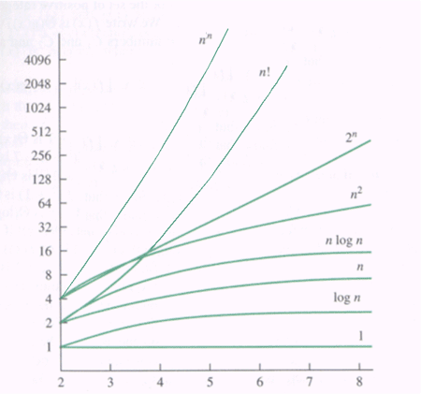
A look at how these functions grow.
b) Big O ave case time - O(n)
c) Big O worst case time - O(n)
d) worst case data set - if key is not found
e) space requirements - one array
f) other characteristics or comments
- easy to write code, okay for small n

2) Binary
a) Big O best case time - O(1)
b) Big O ave case time - O(log n)
c) Big O worst case time - O(log n)
d) worst case data set - if key is not found
e) space requirements - one array
f) other characteristics or comments
- data must be ordered

TODAY’S AGENDA – Class #24

- Discuss topics we learned in Vehicle.
- Take a closer look at Big O.
- Program Lab 1.

LAB 3 – “20,000 Lights”

[Some of you may have seen this last year and/or know the answer. That is NOT the issue here. The purpose of this assignment is for you to build an algorithm to solve the problem, not write an algorithm to print the answer!]

A room has 20,000 light bulbs, each with its own pull-string. Twenty-thousand people walk into the room, one at a time. The first person pulls each string, turning all the lights on. The second person pulls every second light bulb’s string (the 2nd, 4th, etc.) The third person pulls every third string, the fourth every fourth, and so on. Eventually the twenty-thousandth person pulls the string on the twenty-thousandth light.

A) How many light bulbs are on?
B) Which light bulbs are they?

WHAT I EXPECT
- In the folder called “Labs” create a new project called “Lab1Lights”
- Create an application program called “Lab1Lights”
- All you will need is a main method.

METHODS
- There are a few different ways to answer this problem. We will discuss them.

This lab is worth 20 points. If you can figure out part A, then you should easily be able to get the answer to part B.

